INFOhio’s Open Space is a Place for
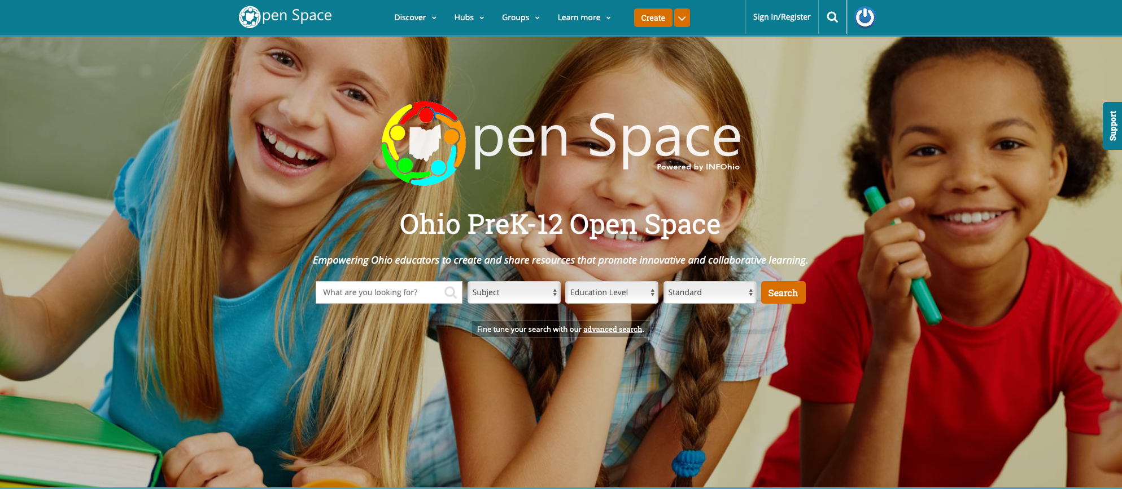
Creation and Collaboration for Ohio Educators

Being an educator has its challenges. How many hours do you spend searching for a lesson plan that meets your needs, only to find that you are not allowed to edit it? How often have you wished that you could collaborate with another educator to create the perfect learning resource, but you don’t know who that educator would be or where to connect with him?

INFOhio’s Open Space solves these challenges. As INFOhio’s newest open educational resource (OER) platform, Open Space empowers Ohio’s PreK-12 educators to create and share digital learning tools that promote innovative and collaborative learning. Developed in partnership with the Institute for the Study of Knowledge Management in Education (ISKME), Open Space provides Ohio’s educators a unique collaboration platform that allows educators to create a free community of creation and collaboration for all of Ohio’s educators.

Ready to create and collaborate with educators across the state? Signing up is easy! Visit https://openspace.infohio.org/ and click the Sign In/Register link at the top right to create your account today. You can also view this video to get started.

Open Space, built on the OER Commons infrastructure with consultation from the Open Space Advisory Council, is the newest addition to INFOhio's suite of OER tools, which are freely available to Ohio’s PreK-12 students and educators. To learn more about INFOhio and OER, please visit www.infohio.org/oer. For questions regarding Open Space, OER, or any of INFOhio’s OER resources, please send INFOhio a note at support.infohio.org.

Updates to INFOhio’s Educator Tools
Gives Educators More Options

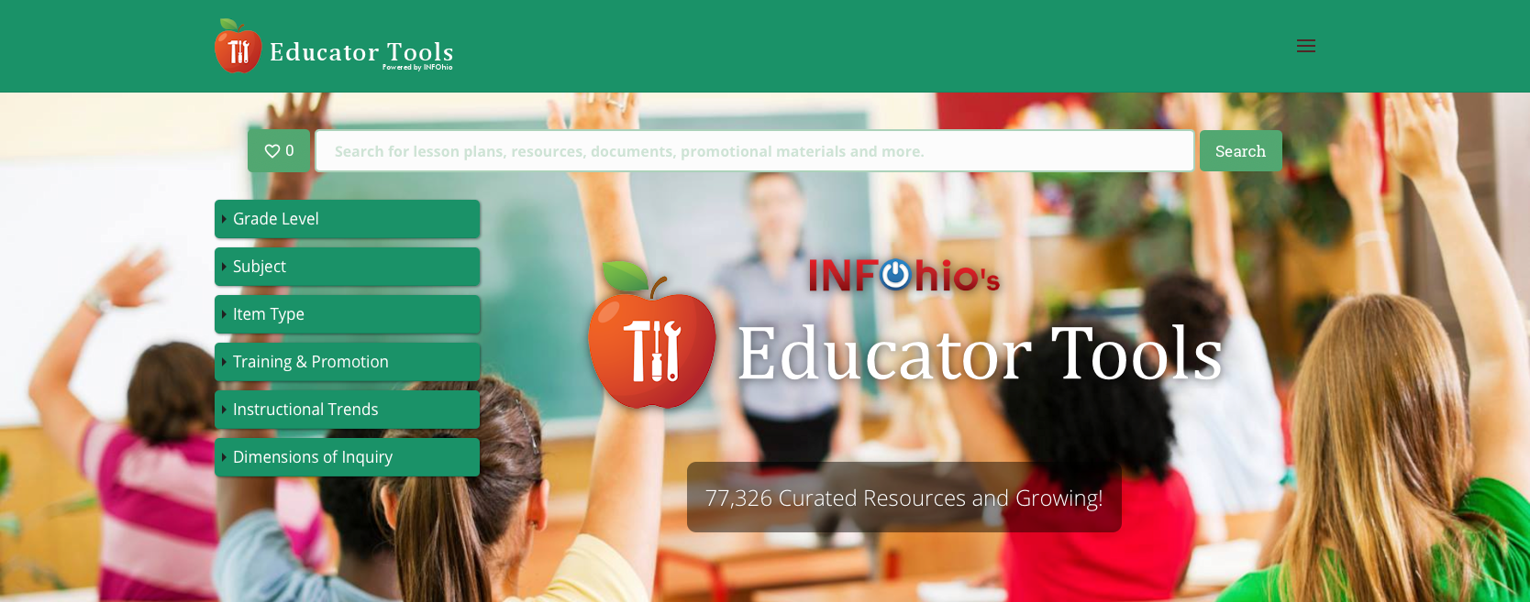

Educator Tools, powered by INFOhio, has been updated to make it easier for teachers to find high-quality, standards-aligned, open educational resources for second semester teaching and learning.

Educator Tools now includes more than 70,000 teacher-approved lesson plans, assessments, best practices, and other instructional resources from the Knovation Content Collection, giving Ohio’s educators resource options. Knovation, powered by ACT, has a team of education professionals who use a 127-point rubric to evaluate the instructional materials included in the Knovation Content Collection.

Now you can link directly to resources from your Google Classroom. Once you have searched Educator Tools, click on the blue “i” button in the result tile to display the list of linking options. You can add the resource link to your website, from within your LMS, and now from Google Classroom!

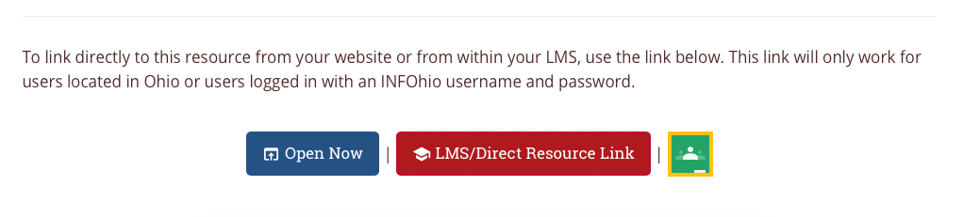

With Computer Science and Social and Emotional Learning standards on the way, new limiters have been added to the Subject limiter category. New Item Type and Instructional Trends limiters were also added – all to help you find resources you need quickly and accurately.

In INFOhio’s Educator Tools, find high-quality learning resources for all grades, all subject areas, and all learning resource types to differentiate and personalize learning for your Ohio PreK-12 students.

If you have questions about Educator Tools or suggestions for additional features, contact INFOhio at support.infohio.org.

#INFOhioWorks for Kindergarten Readiness:
INFOhio’s Early Learning Portal
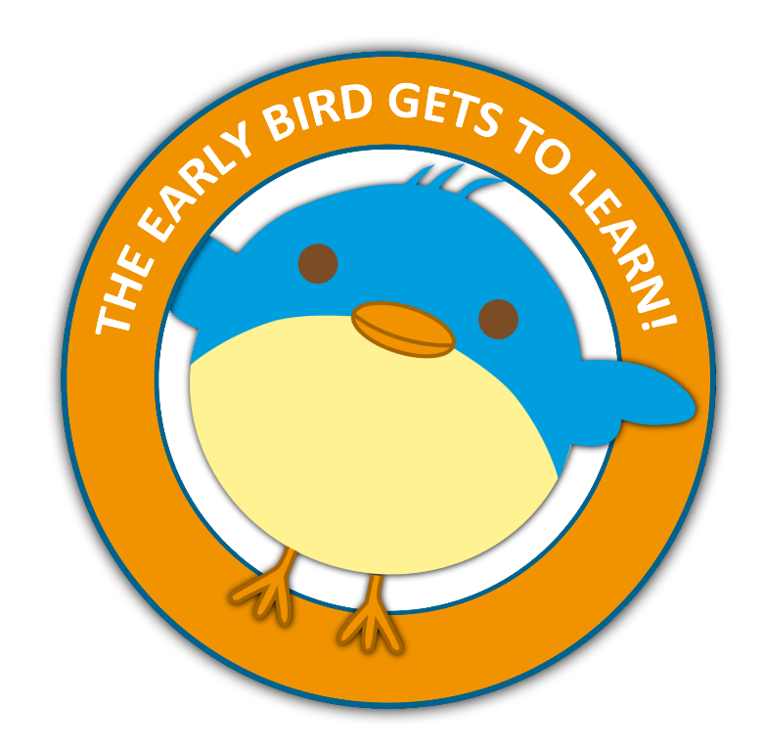
As the calendar pages turn to the Spring months, schools begin to think about their newest students: the kindergarten class of fall 2019. The Class of 2032 will begin bright-eyed and hopefully, kindergarten-ready. What does that mean? While every child is different and develops at his own pace, certain milestones are expected for kindergarten-ready students, and INFOhio can help each student achieve them.

The INFOhio Early Learning Portal supports early learning by providing over 50 websites and apps that are aligned to Ohio’s Early Learning Standards. To help your child be kindergarten-ready, first check out Bold Beginning’s milestones. Is there an area where a child may need some help? Next, check out the resources found on INFOhio’s Early Learning Portal to help your child in those areas. Use the app Breathe, Think, Do to help children make decisions and control behaviors. BookFlix, KidLit TV, and Early World of Learning model storytelling, and Draw and Tell gives them a platform to create and narrate their own stories. Get children moving with resources like GoNoodle and Storybots.

INFOhio’s Early Learning Portal has resources specifically chosen to help children develop the skills they need to start school. Don’t miss the Tips for Educators Page or the Parent Handout. Both will help you help the kids in your life be ready for whatever kindergarten sends their way.

Do you have questions about INFOhio’s Early Learning Portal? Reach out to INFOhio at support.infohio.org.

INFOhio Presentations from OETC

Did you attend an INFOhio session at OETC and you would like the PowerPoint to use as a resource? If so, be sure to check out this list of all the INFOhio presentations with PowerPoints.

If you have any questions, please reach out to support.infohio.org.

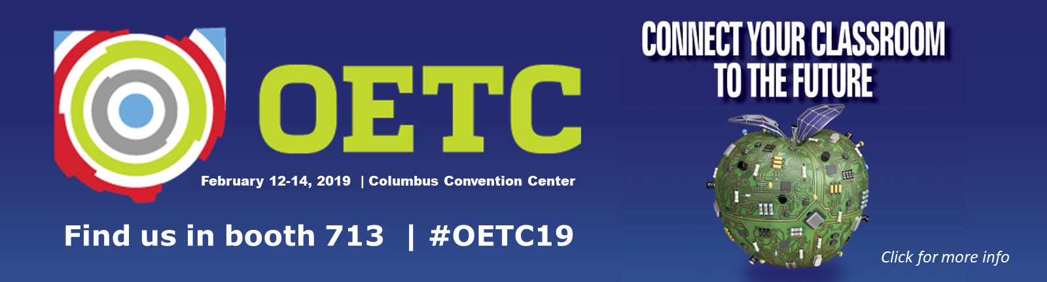

INFOhio Spotlight: EBSCO Highlights Advocacy Lessons Learned

Thanks to your dedication, INFOhio was recognized with the John Cotton Dana Award in 2018 for the advocacy efforts that restored funding for digital content. EBSCO highlighted INFOhio’s advocacy story in a blog post mid-February. Three lessons were learned through INFOhio’s journey that you can apply to your own advocacy efforts.

INFOhio learned that advocacy communication must follow a few simple guidelines:

- Be clear, concise, and continual. When it comes to advocacy, INFOhio learned that communication with legislators must be year-round, not just at the budget cycle.
- Be impactful to decision-makers. It was crucial that legislators heard from the audience that means the most to them — and it wasn't INFOhio. It was the tax-paying citizens of the state, the legislator's constituents — you!
- Tell a story. The campaign wasn't just about the usage facts. It was about the students, teachers, and parents that rely on INFOhio’s digital resources every day.

Thank you for your support of INFOhio that helped restore $1.4 million for digital content.

For questions about INFOhio’s advocacy efforts, please contact INFOhio at support.infohio.org.

