2019 End-of-Year Checklist for Libraries

The following are suggested tasks to complete before the end of school:

- LIB1’s need to enter closed dates for the upcoming school year calendar(s). LIB1’s need to enter closed dates for the upcoming school year. If you charge fines, make sure you close dates for the summer months to prevent overdue fines from accruing while the library is closed. All buildings need closed calendar dates entered. Please contact NEOMIN if you do not have LIB1 access and cannot enter your library’s closed dates.
Login to Workflows:
  - Common Tasks wizard >> Library Calendar
    - Refer to Workflows Handbook: Setup, Getting Started, Library Calendar

- Submit compulsory return date(s) to NEOMIN via email.

- Run overdue reports for staff and students. You can create whole sheet or half sheet notices to distribute to users to notify of their overdue/lost item(s). NOTE: Once in Word, add your school logo in the header to make it appear more “official”. See handout, “Various Library Overdue Reports” for instructions.

- Batch deletion using global item modify wizard. If you are weeding items from your collection, save time by using the Global Item Modify wizard to change the item’s shelf location from available to DISCARD (or WEEDED). You can also use this wizard to mass change various item values such as price, item group, item library, and funding source just to name a few.

- Find items that are long overdue (due before August 2018) and mark them as lost. If an item has not returned during the school year, it’s time to mark that item as lost and charge the user for the amount of the item.
  - Schedule New Reports >> INFOhio tab >> CIR: Overdues and Notices
    - User Options tab >> User Status: Both
    - User Selection tab >> User Profile: exclude faculty, if desired
    - Checkout Selection tab:
      - Add your Library (or leave blank to get all schools in your district)
      - Date due: “<08/01/2018” (before Aug. 1, 2018)
    - Output Options tab:
      - Brief
      - Uncheck “Start New Page on Sort Key”
      - Uncheck “Unpaid Bills”
      - Uncheck “Total Bills and Charges”
    - Run Now. When opening the finished report, only view the result.
    - Use the list of names to Mark Items Lost under Item Maintenance.

- Identify and cleanup inactive patrons with overdue item(s). These are students who left the district and/or seniors who still have an item(s) checked out. If you know that you will not recover the item, you can mark it as lost (if you want to keep the student in the system); or you can check-in the item, remove the student record, and mark the item as missing.
  - Schedule New Reports >> CIR: Overdues and Notices
    - User Options tab >> select “Both”
    - User Selection tab >> add school (or leave blank to select all)
    - User Selection tab >> Privilege exp. date as “<07/01/2019” (Before July 1, 2019)
    - Checkout Selection tab >> Overdue indicate “Both”
    - Output options tab >> uncheck “Start New Page on Sort Key”. Run Now.
    - When opening the finished report, only view the result.

- Review Library Staff accounts and provide NEOMIN with appropriate additions/changes in staffing (not faculty).
  - To view existing staff accounts: Go to User Maintenance wizard >> Display User
    - Search for: “Building code$” (ex. LAKHS$)
    - Index: User ID
    - Library: ALL_LIBS
  - Look through the list of names (ignore the system ones) and notify NEOMIN of any removals

- Clear items in transit as needed. Use the 'Pending Transits' wizard to check if there are any items 'in transit' to your building.
  - Check to see if the item is on your shelf.
  - If you have the item, use the Pending Transits wizard (Special Circ menu) and receive the item. This lets you choose the title from a list. You can also use the Receive Items in Transit wizard if you have the barcode number and want to scan or paste it in.
  - If you don’t have the item, use the Check Item status wizard to see who borrowed it. Contact them to get it returned. If they don’t have it, use the Mark Item Missing wizard to change status to Missing.

- Remove any titles that were not completed during the SmartPort cataloging process. These titles WILL display in CAT/Cat. Jr. and should be removed if you are not adding items to them. You can easily find these because their call number starts with “XX”.
  - Cataloging wizard >> Remove Item
    - Search for: “XX”
    - Index: Call Number
    - Library: YOU MUST SPECIFY A BUILDING
    - Type: Browse
  - Remove the title and XX call number from the tree shown. IF there is a valid barcode listed, you (or a previous staff member) probably forgot to change the call number during the cataloging process. In this case:
    - Click “Close” in the Remove Item wizard
    - Go to Cataloging wizard >> Call Number / Item Maint
    - Do the same search (from previous step searching XX and call number) to find the item record.
    - Modify the call number information to reflect the correct call number. Remember: Never change the Shelving Key (this will update automatically).

- Complete an inventory. It is a good idea to complete an inventory yearly. All you need is a laptop, Notepad, and a scanner! The goal is to update your electronic library records to match what you have in your physical library collection. Reports are of no value if the electronic data does not match what you have on your shelves.
  - Contact Autumn if you need a refresher, cannot attend Inventory training, or would like a one-on-one session.
  - INFOhio’s online handbook has videos on how to complete an inventory in Workflows:
    - Workflows Handbook >> Video Tutorials >> Inventory

- Run Statistics Reports. Use this spreadsheet to find links to all the reports shown below:

  - Circulation Reports
    - Total Checkouts by Item Group
    - Total Checkouts by Grade
    - Total In-House Checkouts
    - Popular Items (Highest circulation items)
  - Population Reports
    - Total Patrons Served
  - Collection Reports
    - Shelf List (shows item status totals, item group totals, total items in library)
    - Total Items by Funding Source for Year
    - Total Value of Collection
    - Total Age of Collection
    - List of New Titles for the Year (and Total Cost)
    - Total Receipts by Payment Type

- Update your Book River in iSearch. A Book River lets you highlight materials in your library on your iSearch landing page. A Book River requires library staff to run a report periodically to maintain a list of "Featured Titles."
  - If you want a book river, open/send an email helpdesk ticket to infohio.support@neomin.org.
  - Once your book river is configured, you will need to determine how you want to populate the featured titles list (there are three different options).

- Optional “favorite” reports to run:
https://www.infohio.org/educators/library/workflows-handbook/category/favorite-reports
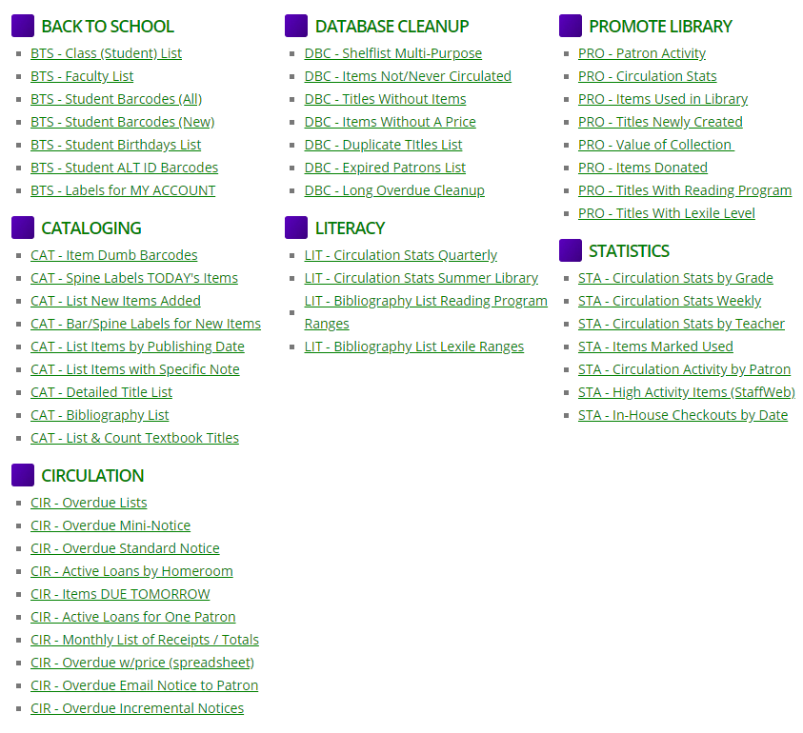

- Run Database Cleanup Reports. You find these reports on INFOhio’s Workflows Handbook >> Reports >> Favorite Reports.
  - (Older) Items that have Not Circulated (in time - range selected)
  - (Older) Items that have Never Circulated
  - Items with No Price Listed
  - Run a shelflist in spreadsheet view to sort various data (item groups, call numbers, etc) to see where issues need resolved.

- Review INFOhio Summer Learning for Students
  - https://www.infohio.org/document-library/category/summer-learning
- Review INFOhio’s Choice Board for Professional Learning
  - https://www.infohio.org/images/_DOCS/toolkit/INFOhioPD.pdf
- Complete End-of-the-Year Surveys (via email)

