BLUEcloud Cataloging
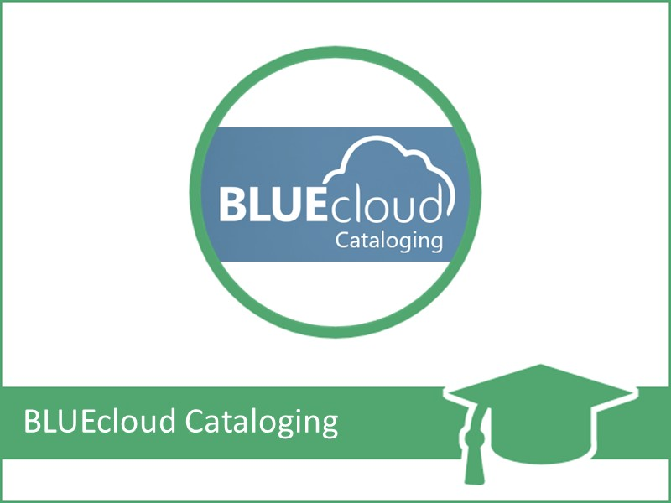
Today’s Goal:
Complete the learning pathway for BLUEcloud cataloging, in a group context, and obtain a 3 contact hour certificate upon completion.
Learning Objectives:
- Successfully log into BLUEcloud Central.
- Set context to the desired institution (school building).
- Search multiple targets and use facets to limit your search.
- Edit bibliographic data manually.
- Edit bibliographic data using shortcuts like drag and drop.
- Update/improve bibliographic records by merging or overlaying data from other databases.
- Create/Edit call number and item/copy records.
- Use a Z39.50 target to import a record.
- Create and Modify records in batch.
- Add a new record using a template.

