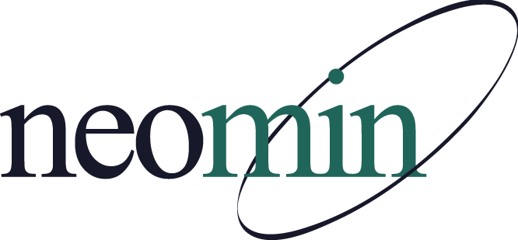

NEOMIN Library Services
Library User Group Meeting
Tuesday, April 16, 2019 at 8:30 AM
NEOMIN Training Lab

Agenda

Welcome Notes
- Autumn will not be at this meeting. Someone from NEOMIN will make sure the lab is open, the projector is on, and everyone is able to login to the computers.
- Certificates provided for those in attendance.
- Please use NEOMIN’s web help desk if you have questions/concerns for library services while Autumn is on maternity leave.
Library Attendance Using Google Sheets
- Laura Henning, TCTC
Circulation: Self-Checkout Station – Ideas & Photos
- Megan Phiel, Hubbard
- Sandy Amoline, Champion
Open Lab
- Everyone is encouraged to work on end-of-the-year reports, cleanup, cataloging, or collaborate with other library professionals.
Adjourn
- First meeting of the 2019-2020 school year to be announced in August 2019

