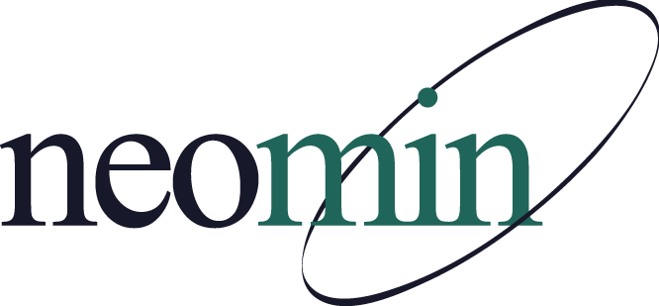

NEOMIN Library Services
Library User Group Meeting
November 15, 2017
NEOMIN Training Lab

Agenda

8:30 AM Overview
We will begin the meeting with a tour of the TCTC's redesigned media center. Jennifer Schwelik, an INFOhio Instructional Team Specialist, will be with us to talk about RS4, the Early Learning Portal, the Future Ready district assessment, and the Future Ready Ohio website. Autumn Dodson, from NEOMIN, will discuss system tips for genre-fying your library collection(s).
Announcements
- Introductions & Meeting Navigation

8:30-9:00 AM TCTC Media Center Tour
- Laura Henning, TCTC Media Specialist and NEOMIN/INFOhio User Council Representative, will guide us through her newly redesigned media center including fab lab, learning commons, and zSpace lab.
INFOhio User Council Representative Changes
- Update on proposed changes by Laura Henning, NEOMIN/INFOhio User Council Representative

9:00-9:45 AM INFOhio Updates by Jennifer Schwelik
- Revised Research 4 Success website - R4S
- NEW INFOhio Early Learning Portal
- Future Ready Librarians
  - Overview of Future Ready
  - District assessment
  - Future Ready Ohio website

9:50-10:00 AM Break
- INFOhio Learn It Clips Survey

10:00-10:30 AM Tips for Genrefying Your Collection Using Workflows
- Review INFOhio suggested “How To” procedure
- Remember to Update Vendor Specifications, if desired
- Manually Modify Call Numbers & Genre for New Items
- Post-Genrefication: Evaluating Your Efforts

10:30 AM Adjourn
- Open Lab: Thursday, December 7, 2017 from 8:00 AM – 4:00 PM
- Next meeting: Thursday, January 11, 2018 at 8:30 AM

