Under reports and notices  Go to the ADMINISTRATION tab  Select the report TRANSACTION STATISTICS  Setup & Schedule | 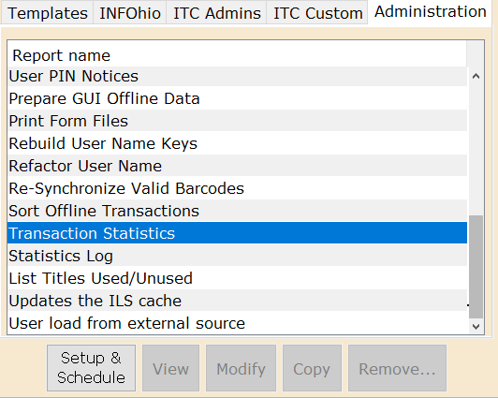
Go to the tab “Transaction Statistics Selection”  The selection on this tab is what is used to find requests.  It is searching the entries in the transaction history.  I admit I was at a loss as to what to search on. I found using the User Profile worked in my tests  For USER PROFILE Select the various student/faculty profiles | 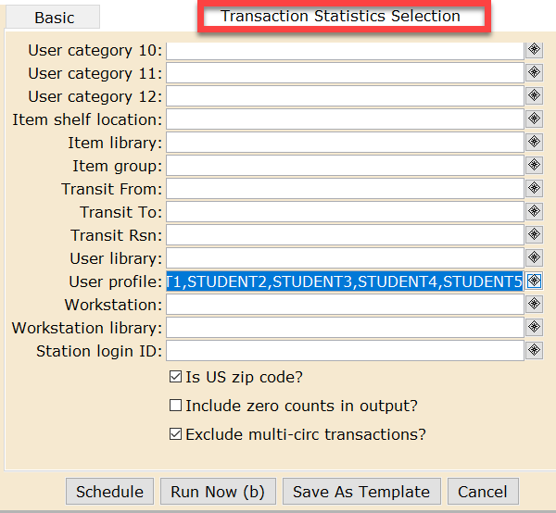
Go to the “Transaction Selection” tab  For COMMAND click the gadget and add “Create Hold” to the list selected | 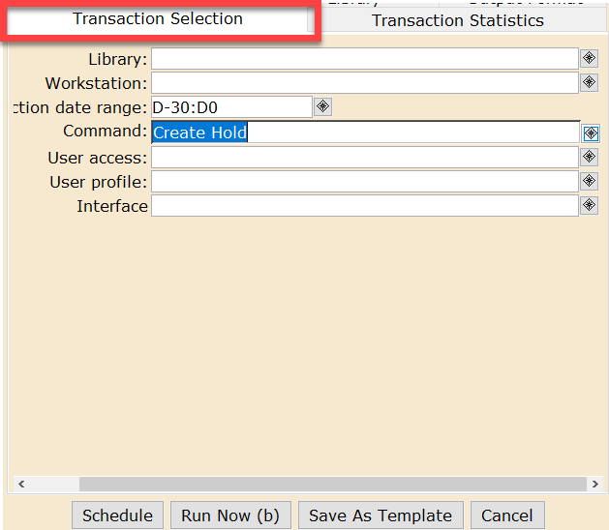
Go to the “Transaction Statistics” tab  Set the COLUMN to Item Library (or you could use USER LIBRARY. Your choice)  Click the RUN NOW button  Click DISPLAY FINISHED REPORTS  When the report appears select it and double click on it  For Row, instead of Total you could use a variety of options to get additional statistics. And it will still give a total at the bottom. | 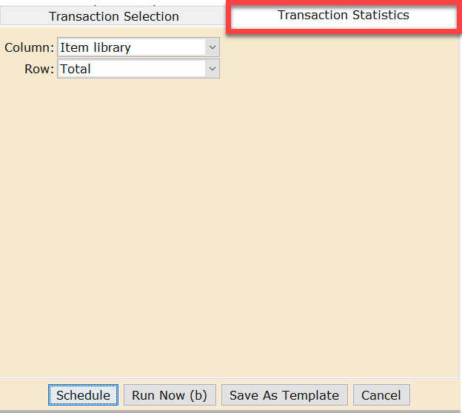
You will want both “View Result” and “Format Report” to be selected  Click the OK button | 