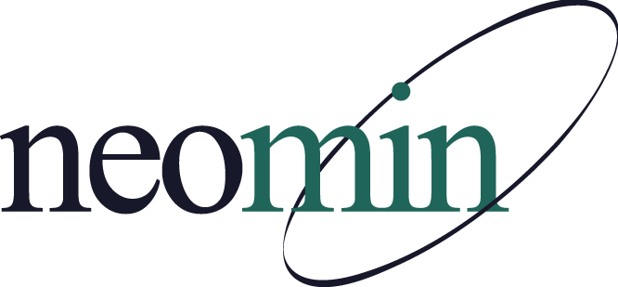

NEOMIN Library Services
Library User Group Meeting
Thursday, Sept. 26, 2019 at 1:30 PM
NEOMIN Training Lab

Agenda
Welcome
- Introductions, Attendance Sign-In, & Meeting Navigation
- Review of Handouts & INFOhio Materials
- INFOhio Guest Presenter: Melissa Solema
- Review of “2018 Library User Group – Meeting Time” Survey Results
NEOMIN Library Services Updates – Autumn Dodson
- ﻿﻿2019-2020 Library User Group Meeting Schedule
- Library User Group Focus & Audience
- Status of NEOMIN Libraries
- NEOMIN Library Training Schedule
- NEOMIN Library Technology Support Page – Updated
- NEOMIN Help Desk
- INFOhio User Council - NEOMIN Representatives
- SirsiDynix Upgrade & Workflows Update
- INFOhio OPAC Timeline – Cat/Cat Jr/ISearch
- ISearch Enhancements & Fall Updates
- BLUEcloud vs Traditional
  - BLUEcloud Cataloging
  - BLUEcloud Circulation
  - MobileCirc & MobileCirc Offline Mode App
  - BLUEcloud Learning Pathway
INFOhio Guest Presenter - Melissa Solema
- INFOhio Mission & Vision
- Digital Resources for a Digital Age – Resources & Tools (handout)
- NEW “INFOhio Campus”
- Support area of INFOhio Quick Links
- “Transforming Instruction. Impacting Learning” (Fall 2019 Presentation)
  - Use the presentation to share INFOhio updates with your community of INFOhio users

Questions/Discussion/Comments

Adjourn
- Next meeting: Tuesday, October 22, 2019 at 1:30 PM in NEOMIN’s training lab

